C PROGRAMMING
NAME :YOKITHA S
ROLL NO: 242801327
WEEK : 8
TOPIC : SORTING ALGORITHMS -BUBBLE AND SELECTION
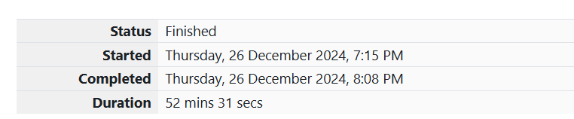
1. Problem Statement:
Coders, here is a simple task for you. You are given an array of size NNN and an integer MMM. Your task is to calculate the difference between the maximum sum and minimum sum of N−MN-MN−M elements of the given array.
Constraints:
1≤t≤101 \leq t \leq 101≤t≤10
1≤n≤10001 \leq n \leq 10001≤n≤1000
1≤a[i]≤10001 \leq a[i] \leq 10001≤a[i]≤1000
Input Format:
- First line contains an integer TTT denoting the number of test cases.
- First line of every test case contains two integers NNN and MMM.
- Next line contains NNN space-separated integers denoting the elements of the array.
Output Format:
For every test case, print your answer in a new line.
Sample Input
Copy code
1
5 1
1 2 3 4 5
Sample Output
Copy code
4

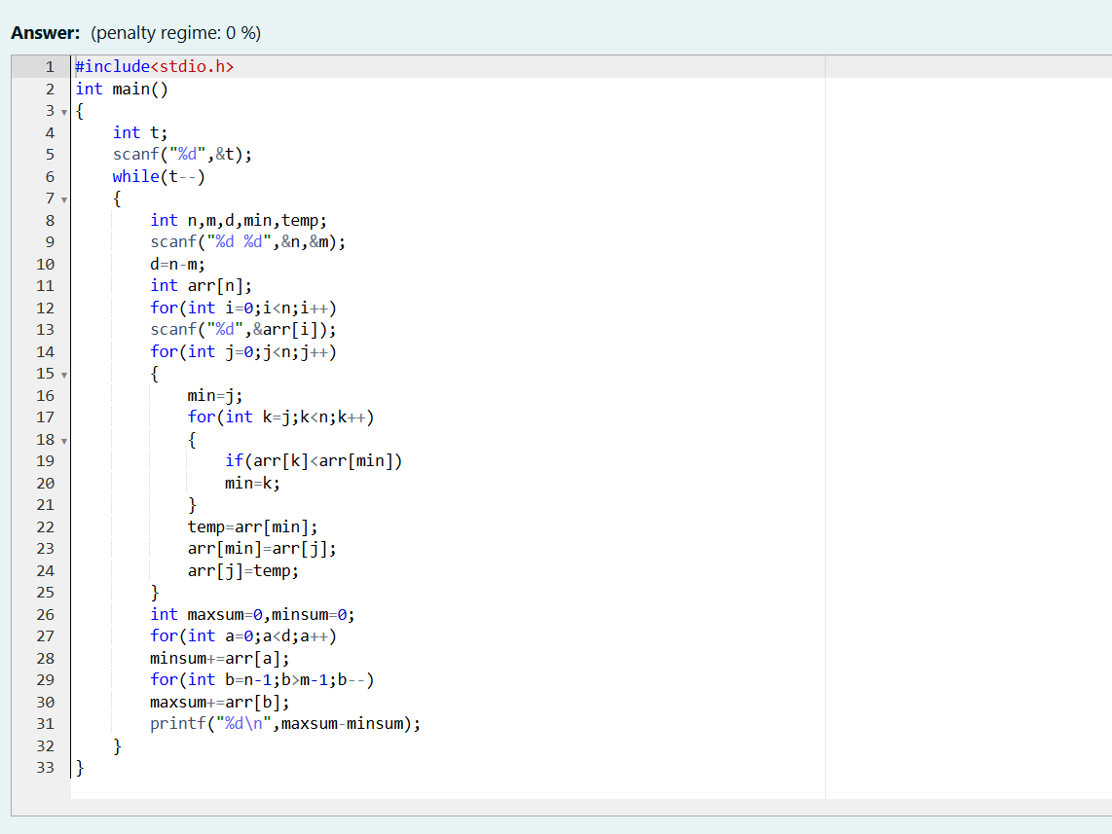
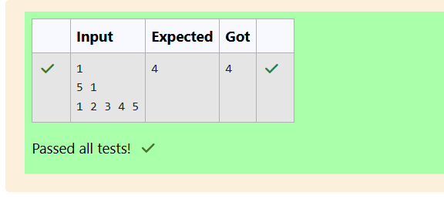
Problem Statement:
You are given an array AAA of non-negative integers of size mmm. Your task is to sort the array in nondecreasing order and print out the original indices of the new sorted array.
Input Format:
The first line of input consists of the size of the array.
The next line consists of the array of size mmm.
Output Format:
Output consists of a single line of integers.

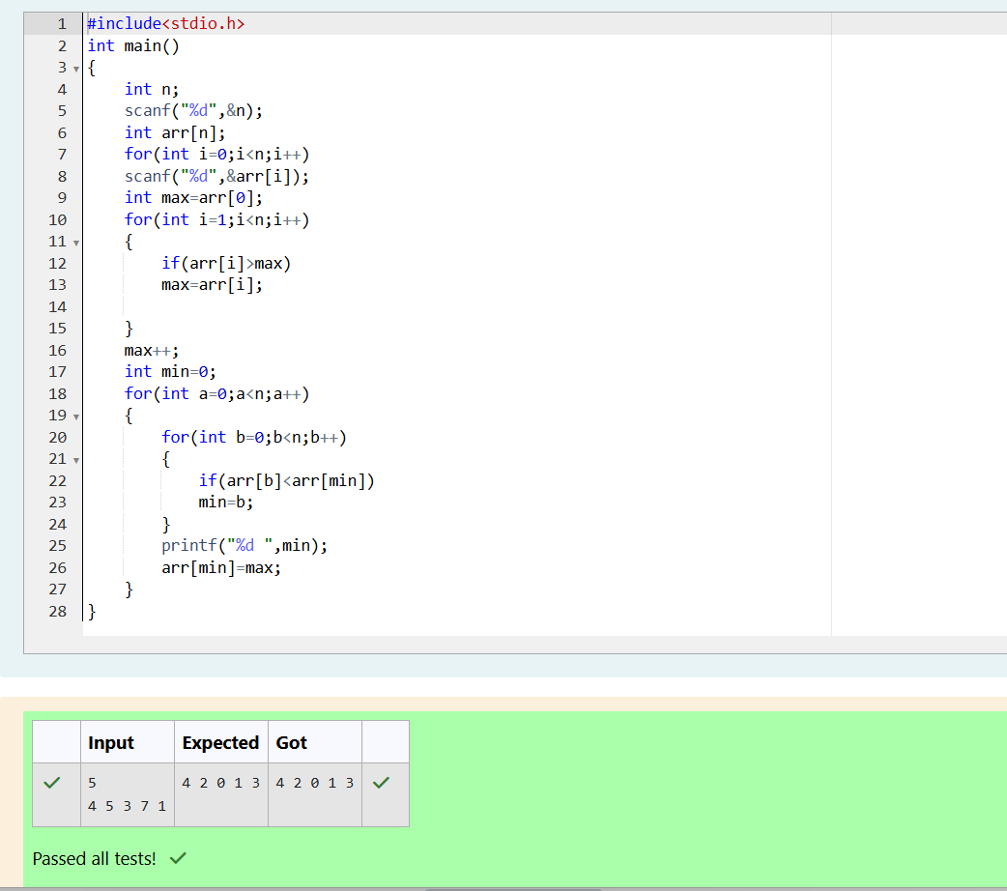
3. Problem Statement:
A new deadly virus has infected a large population of a planet. A brilliant scientist has discovered a new strain of virus that can cure this disease. Vaccine produced from this virus has various strengths depending on midichlorians count. A person is cured only if the strength of the vaccine is greater than the midichlorians count of the patient.
Input Format:
- First line contains an integer NNN, the number of patients.
- The second line contains NNN space-separated integers representing the midichlorians count of the patients.
- The third line contains NNN space-separated integers representing the strength of the vaccines.
Output Format:
Print "YES" if all patients can be cured, otherwise print "NO".
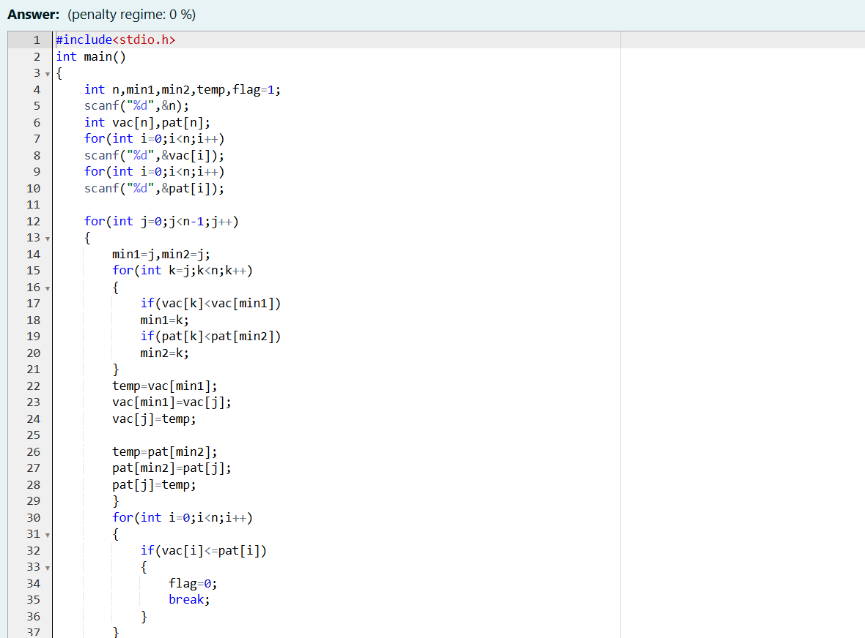

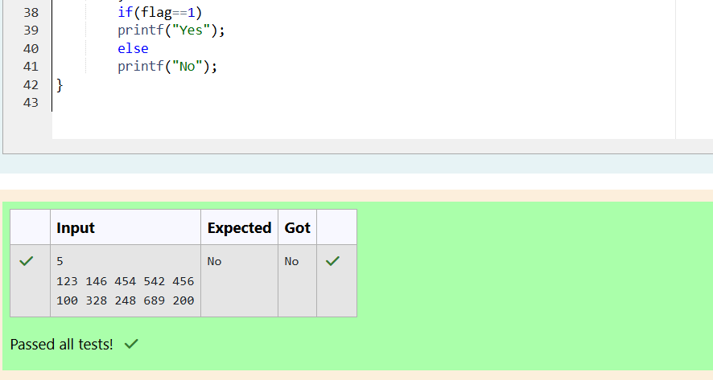
4. Problem Statement:
You are given an array of nnn integer numbers a1,a2,…,ana_1, a_2, \ldots, a_na1​,a2​,…,an​. Calculate the number of pairs of indices (i,j)(i, j)(i,j) such that 1≤i<j≤n1 \leq i < j \leq n1≤i<j≤n and ai⊕aj=0a_i \oplus a_j = 0ai​⊕aj​=0.
Input Format:
- First line: nnn denoting the number of array elements
- Second line: nnn space-separated integers a1,a2,…,ana_1, a_2, \ldots, a_na1​,a2​,…,an​.
Output Format:
Output the required number of pairs.
Constraints:
- 1≤n≤1061 \leq n \leq 10^61≤n≤106
- 1≤ai≤1091 \leq a_i \leq 10^91≤ai​≤109
Sample Input:
Copy code
5
1 3 1 4 3
Sample Output:
Copy code
2
